Name: Period: Date:
Focus Questions for Chapter 8.4 (Enzymes) due Thursday, 10/31

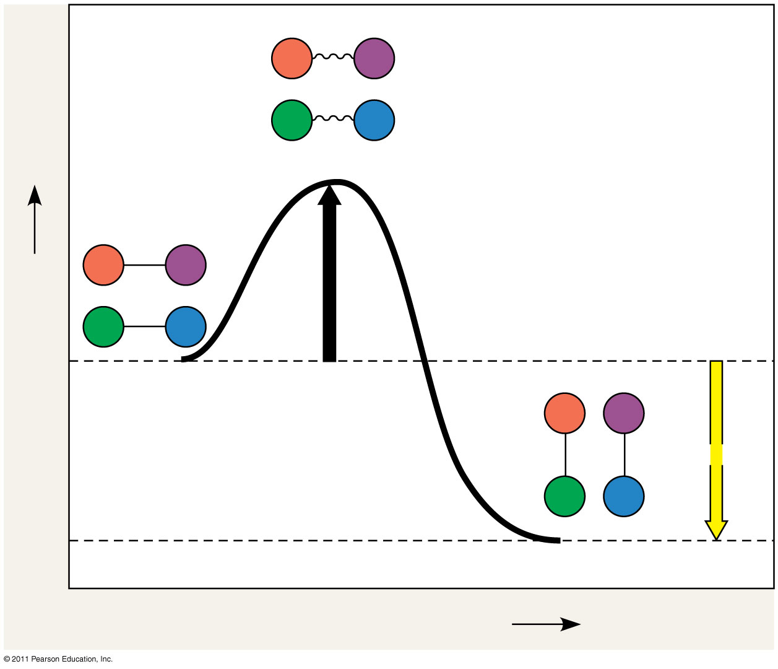
Questions to answer as you read about enzymes. You will not be asked to turn these in, but Ms. Ransom may check to make sure you have completed them through a clicker quiz or short written response. You should be ready to discuss the answers during class.
- How does an enzyme catalyze a chemical reaction?
- What does E_{A} stand for? What does this mean?
- Explain in words what is being shown in the figure to the right. Label the image.
- Can an enzyme change the total amount of energy used/given off by a reaction? Explain.
- What does “substrate specific” mean? What implication does this have on the types (and concentrations) of enzymes in your body?
- Summarize what happens during an enzyme-catalyzed reaction (induced fit).
- What environmental factors can affect enzyme activity? How do they affect it?
- What do cofactors/coenzymes do? What is the difference between them?
- Compare and contrast competitive and noncompetitive inhibitors (you may use a Venn diagram if you wish). Include examples.
- How can the study of enzymes, which is a part of Big Idea #2 (Biological systems utilize energy and molecular building blocks to grow, to reproduce, and to maintain homeostasis.) relate to what we studied in Big Idea #1 (The process of evolution drives the diversity and unity of life.)?

