Name: Period: Date:
Focus Questions for Chapter 55.2 (Primary Productivity) due Wednesday, 4/23

Questions to answer as you read about primary production. You will not be asked to turn these in, but Ms. Ransom may check to make sure you have completed them through a clicker quiz or short written response. You should be ready to discuss the answers during class.
- What is primary production? Why is it important?
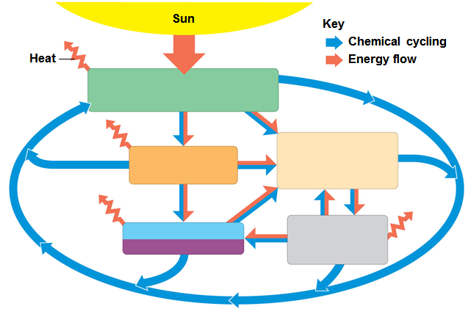
- What types of organisms are primary producers?

- Label the figure to the right.

- Explain the difference between gross primary production (GPP) and net primary production (NPP). What is the formula that relates them?
- What is net ecosystem production (NEP) and how is it calculated?
- What are some common limiting factors in aquatic ecosystems? Terrestrial?

Questions I have that I plan to ask about in class:

