Name: Period: Date:
Focus Questions for Chapter 17.4 (Translation) due Thursday, 2/13

Questions to answer as you read about translation. You will not be asked to turn these in, but Ms. Ransom may check to make sure you have completed them through a clicker quiz or short written response. You should be ready to discuss the answers during class.
- What is the role of tRNA in translation?
- What is an anticodon? Briefly describe the structure of tRNA. You may sketch it if you prefer.
- The correct pairing of amino acid to tRNA molecule is accomplished by a(n) _____________________________ called ________________________________________________________.
- What is wobble and why is it important? And we’re not talking about the dance…

- What is rRNA, why is it important, and where does it come from?
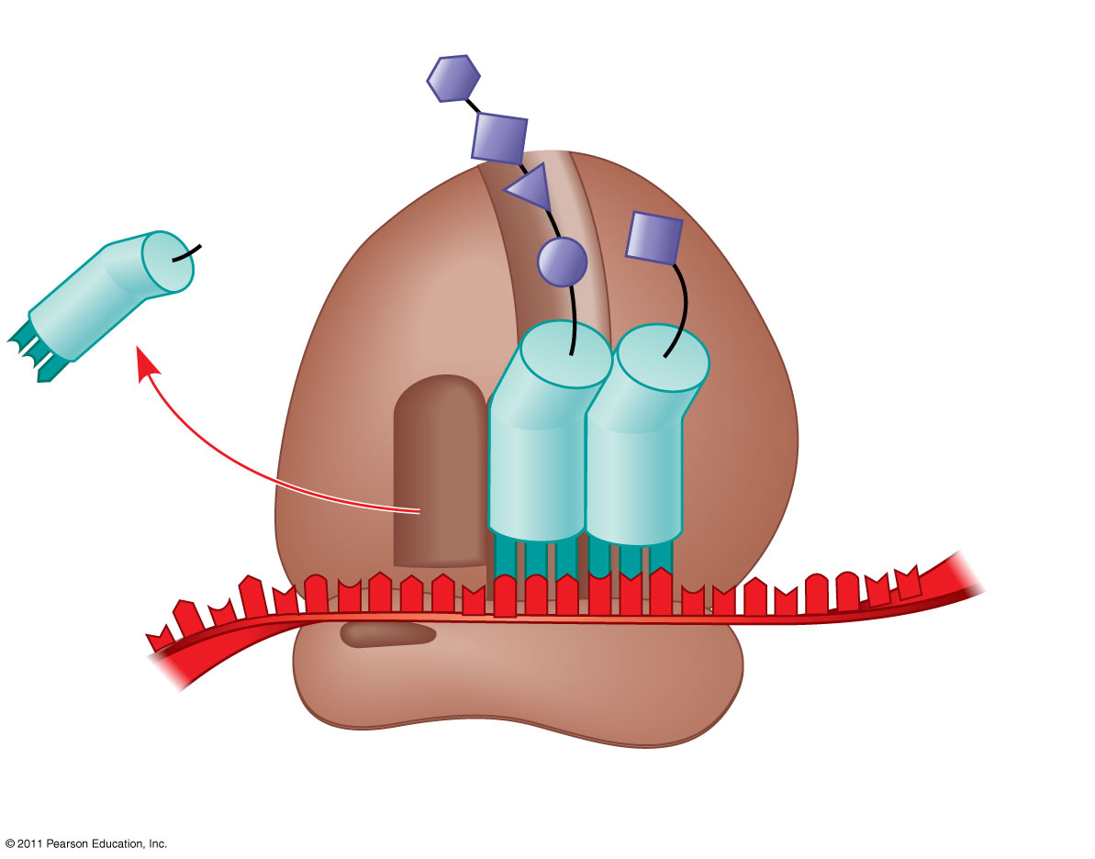
- Do prokaryotic ribosomes differ from eukaryotic ribosomes? If so, how?

- Label the ribosome diagram to the right and briefly describe the significance of each part:
- What triggers the termination of translation?
- What are polyribosomes and why are they important?
- What happens to the newly translate polypeptide before it becomes a functional protein?
- How do the function and location of free ribosomes compare to bound ribosomes?
Questions I have that I plan to ask about in class:

