Name: Period: Date:
Focus Questions for Chapter 10.1 (Photosynthesis Overview) due Tuesday, 3/18

Questions to answer as you read about photosynthesis. You will not be asked to turn these in, but Ms. Ransom may check to make sure you have completed them through a clicker quiz or short written response. You should be ready to discuss the answers during class.
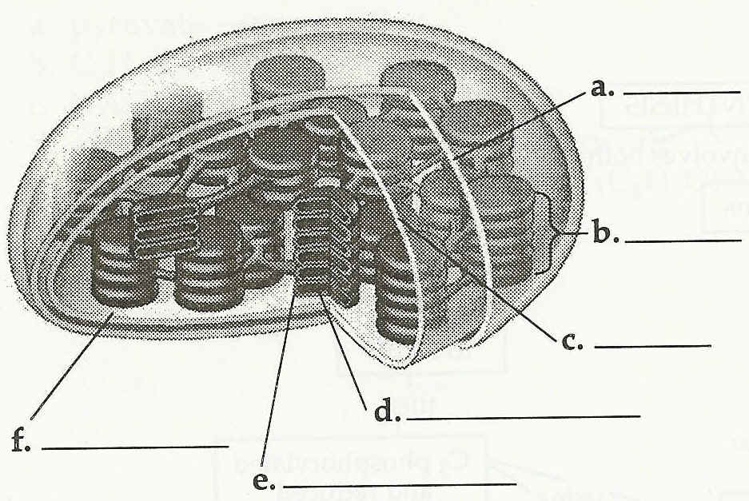
- What is mesophyll? Stomata? How do they relate to photosynthesis?
- Label the parts of a chloroplast as shown to the right:
- Write the overall equation of photosynthesis. Why is water shown on both sides of the arrow? If you reduce the equation to its simplest form, what would it be? (The point of this question is to really get you to understand the chemistry of what’s going on.)
- Where does the oxygen come from that is released as a byproduct of photosynthesis?
- Photosynthesis is known as a redox reaction (for reduction/oxidation). If you are unfamiliar with redox reactions as a concept, there is an explanation on page 164. What becomes reduced and what becomes oxidized?
- What are the two stages of photosynthesis called?
  - ________________________________________
What happens in this step (general description, not specific chemical reactions)?
  - ________________________________________
What happens in this step (general description, not specific chemical reactions)?
- What is Nicotinamide Adenine Dinucleotide Phosphate (NADP⁺)?
- What is photophosphorylation?
- What is carbon fixation?

