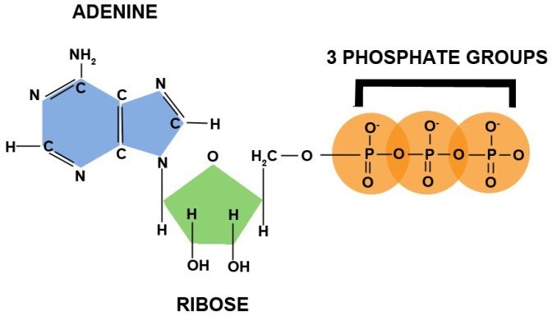**ATP - Power To Drive Cellular Work**



ATP - Adenosine triphosphate - a close relative to Adenine, a nucleotide found in DNA.



* Contains three phosphate groups connected to each other in sequence



* The bonds can be broken by **hydrolysis**



* + When the terminal phosphate bond is broken, a molecule of inorganic phosphate (Pi)  is released



* + This converts ATP to adenosine **di**phosphate, ADP + (Pi)



* + This generates free energy, which can be used by the cell to do work  
    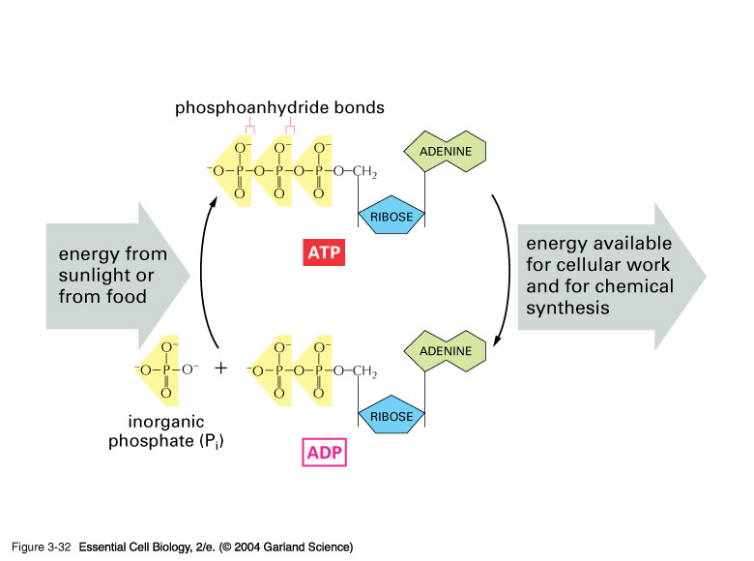



* + ATP-coupled reactions: the free energy released during one (exergonic) reaction is used to power a separate (endergonic) reaction



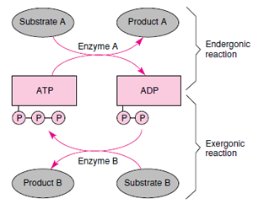



* Usually, ATP functions by transferring its phosphate group to another molecule, creating a **phosphorylated intermediate**.
  + This phosphorylated intermediate is usually *less stable (more reactive)* than the original molecule, which drives the reaction



* + Examples:



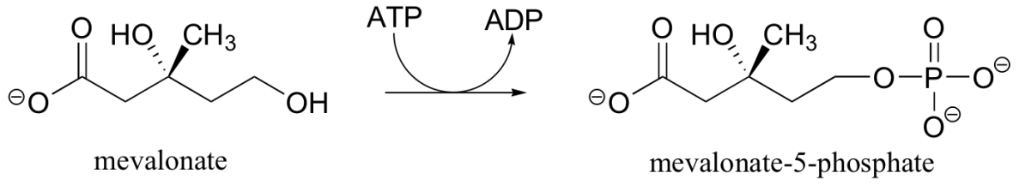

[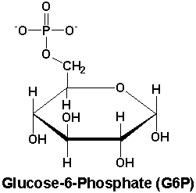](http://www.google.com/url?sa=i&rct=j&q=&esrc=s&frm=1&source=images&cd=&cad=rja&docid=aFy5fWPOgZsydM&tbnid=hs6defPNoMBJuM:&ved=0CAUQjRw&url=http://www.pearsonhighered.com/mathews/molex/g6p.htm&ei=kYV7UuShIYPVkQf4hoDAAQ&bvm=bv.56146854,d.eW0&psig=AFQjCNFdzwkXOc12P3XSZBljPJf_ncTq5g&ust=1383913133828430)

* Obviously, for the cell to function, ATP must rapidly be regenerated.
  + One muscle cell can consume and regenerate over 10,000,000 ATP molecules a second
  + If ATP couldn't be regenerated, humans would have to consume nearly their *body weight* in ATP each day