Name: Period: Date:
AP Biology Lab #12: Animal Behavior
- What question were you investigating in this lab? _________________________________ ______________________________________________________________________________________________________________________________________
- What was your hypothesis? Phrase as an if/then statement. __________________________ ______________________________________________________________________________________________________________________________________
- Briefly describe how you addressed each of the considerations listed below:
  - Independent variable: ______________________________________________
  - Dependent variable: _______________________________________________
  - Control: _______________________________________________________
  - Constants: ______________________________________________________
  - Replication: _____________________________________________________
  - Sources of error: … and how you minimized them:
________________________________ __________________________ ________________________________ __________________________ ________________________________ __________________________ ________________________________ __________________________ ________________________________ __________________________
- Graph your data:
- Calculate a Chi-Squared value for your data.
  - What is your null hypothesis (H₀)? ___________________________________ ______________________________________________________________
  - What is your alternate hypothesis (H_{alt})? ______________________________ ______________________________________________________________
Remember:
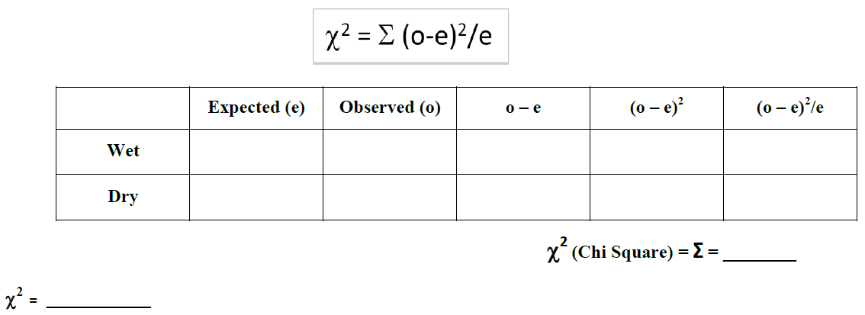
degrees of freedom (# possible outcomes – 1): ________
Critical value at p = 0.05 __________ (Use the formula sheet in Appendix A of the lab manual)
*You may wish to analyze multiple data sets even though the chart only lists two choices. *
- What can you conclude from this experiment? (Hint: you should base your conclusion on your Chi-Squared value) _____________________________________________________ ____________________________________________________________________________________________________________________________________________________________________________________________________________________________________________________________________________
- Offer a scientific explanation for your results. Use the internet or textbook to look up background information if you need to. Cite the source(s) used!
_______________________________________________________________________________________________________________________________________________________________________________________________________________________________________________________________________________________________________________________________________________ Source(s):____________________________________________________________ ______________________________________________________________________________________________________________________________________
- What other questions might be interesting to research if you were to do this experiment again? _________________________________________________________________________________________________________________________________________________________________________________________________________

